Practical No: 2
Aim: Implement MapReduce and Hadoop.
Running Hadoop natively on Windows is complex because Hadoop is built for Linux. To make it work, we need a specific "patch" called winutils.exe. SO, Provided in google classroom along with this file.

Phase 1: Downloads & Prerequisites
- Install Java 8 (JDK 1.8):
  - Hadoop requires Java 8. Newer versions (Java 17/21) often cause errors.
  - Download JDK 8 for Windows (x64).
  - Install it to a simple path like C:\Java\jdk1.8.0 (Avoid spaces like "Program Files" if possible).
- Download Hadoop:
  - Download Apache Hadoop 3.3.6 (Binary download).
  - Extract the folder to the root of your C: drive so the path is exactly: C:\hadoop-3.3.6.
  - Action: Copy winutils.exe and hadoop.dll and paste them into your C:\hadoop-3.3.6\bin folder.

Phase 2: Configuration
You need to edit 4 files located in C:\hadoop-3.3.6\etc\hadoop. Open them with Notepad.
1. core-site.xml
Paste this inside the <configuration> tags:

<configuration>
<property>
<name>fs.defaultFS</name>
<value>hdfs://localhost:9000</value>
</property>
</configuration>
2. mapred-site.xml

<configuration>
<property>
<name>mapreduce.framework.name</name>
<value>yarn</value>
</property>
</configuration>

3. hdfs-site.xml
(Create a folder C:\hadoop-3.3.6\data\namenode and C:\hadoop-3.3.6\data\datanode first)

<configuration>
<property>
<name>dfs.replication</name>
<value>1</value>
</property>
<property>
<name>dfs.namenode.name.dir</name>
<value>file:///c:/hadoop-3.3.6/data/namenode</value>
</property>
<property>
<name>dfs.datanode.data.dir</name>
<value>file:///hadoop-3.3.6/data/datanode</value>
</property>
</configuration>
4. yarn-site.xml

<configuration>
<property>
<name>yarn.nodemanager.aux-services</name>
<value>mapreduce_shuffle</value>
</property>
<property>
<name>yarn.nodemanager.auxservices.mapreduce.shuffle.ckass</name>
<value>org.apache.hadoop.mapred.shuffleHandler</value>
</property>
</configuration>

5. hadoop-env.cmd Find the line set JAVA_HOME=... and change it to your Java path (use "short names" if there are spaces, or put it in quotes).
- Example: set JAVA_HOME=C:\Java\jdk1.8.0
(note: path should not have empty space)
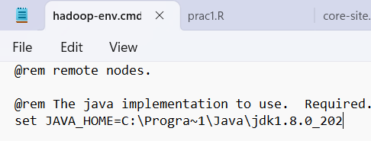

Phase 3: System Environment Variables
- Press Win + S, search "Edit the system environment variables".
- Click Environment Variables.
- Create New System Variables:
  - HADOOP_HOME -> C:\hadoop-3.3.6
  - JAVA_HOME -> C:\Java\jdk1.8.0
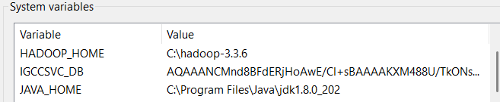
- Edit the "Path" Variable:
  - Add: %HADOOP_HOME%\bin
  - Add: %HADOOP_HOME%\sbin
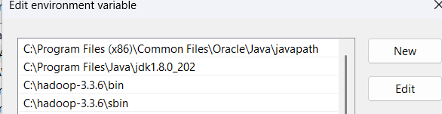

Phase 4: Run the Practical
- Format the Filesystem:
Open Command Prompt as Administrator and type:
hdfs namenode -format
(Look for "Storage directory has been successfully formatted".)

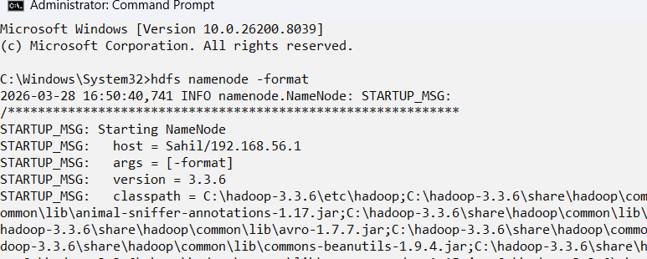
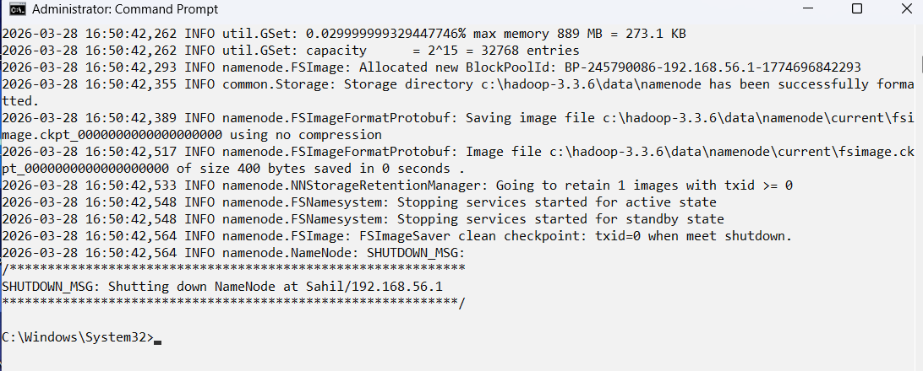
- Start Hadoop:
Run the following command:
start-dfs.cmd
(Two new windows should pop up: NameNode and DataNode.)

Datanode window:

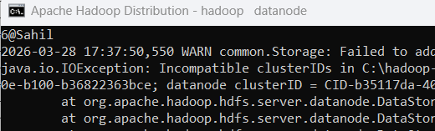

Name node window:

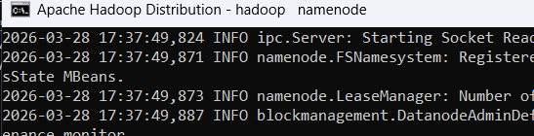

Then run:
start-yarn.cmd
(Two more windows: ResourceManager and NodeManager.)
ResourceManager:
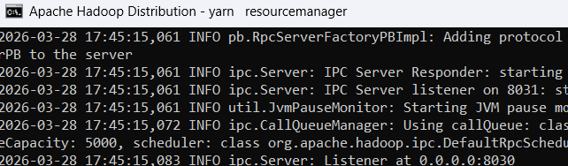
NodeManager:

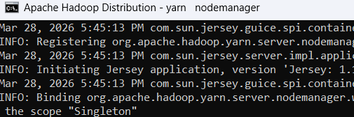
- Run the MapReduce Job (WordCount):
  - Step A: Create Input. Create a text file input.txt with some text (e.g., "Hello Hadoop Hello World").
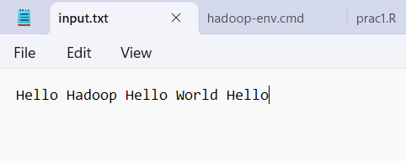
  - Step B: Upload to HDFS.
hdfs dfs -mkdir /input
hdfs dfs -put input.txt /input/
(or full path: hdfs dfs -put C:\Users\Sahil\input.txt /input/)


  - Step C: Run the Job.
(Using the example JAR that comes with Hadoop):
hadoop jar C:\hadoop-3.3.6\share\hadoop\mapreduce\hadoop-mapreduce-examples-3.3.6.jar wordcount /input /output
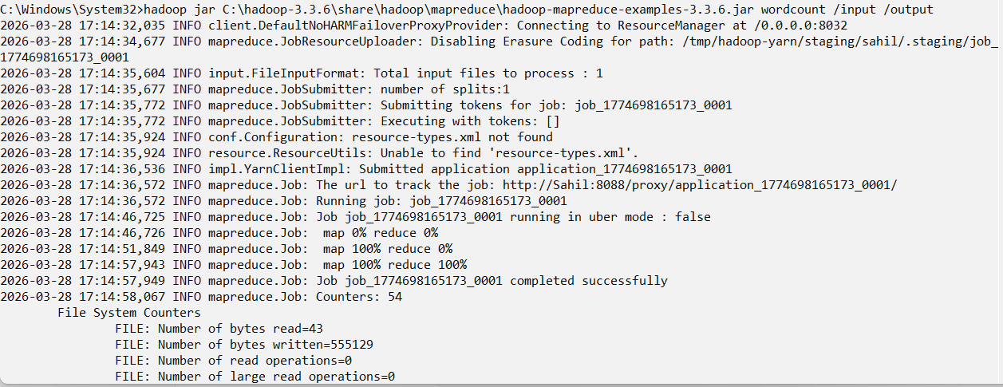
Step D: only if error then output already exist
hdfs dfs -rm -r /output

Step E: show Output
hdfs dfs -cat /output/part-r-00000
Expected Output:

